OCMT

MINIONS 2

sTALIN, sRINATH  GOPINATH, MURALI .M.K

ONE CLICK MULTIPLE TRANSFER

One Click Multiple Transfer

Transfer money to multiple people at single click

Idea: An Account holder in NBS can transfer money to multiple people at same time with different beneficiaries who holds account within NBS or Other Banks

# A SCREEN FLOW TO UNDERSTAND THE IDEA

Home Screen:

Home Screen

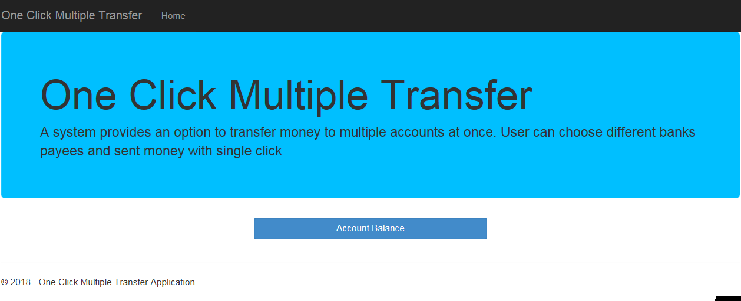

Account Balance screen

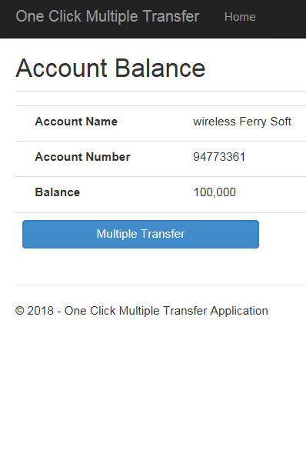

Transfer Screens 1

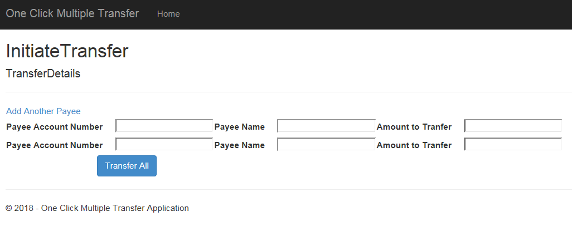

Transfer Screen 2

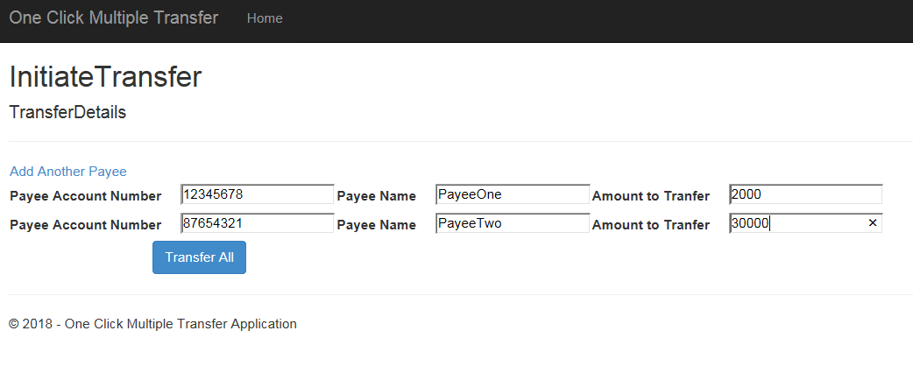

Confirm Transfer

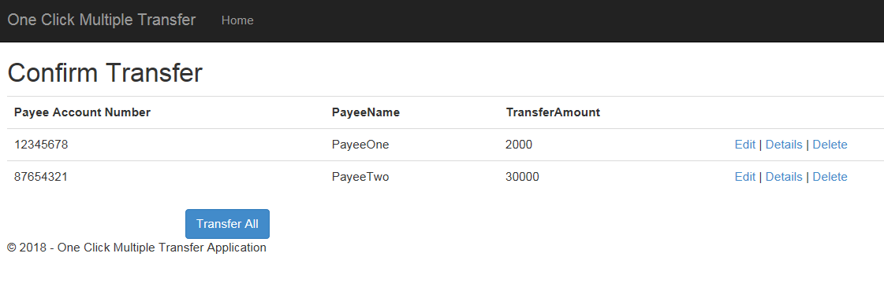

Transfer Summary

